The 4+1 Architectural View Model
The 4+1 Architectural view model has been developed to make visualizations of software architectures more understandable by organizing them in 4 views and a fifth view to explain the semantics of the other views.
For each view we define a set of elements to use such as components, containers and connectors.

Logical View
Describes the Objects of the system (OO Design). The logical view primarily supports the functional requirements. These abstracions are objects of object classes that use abstracion, encaplsulation and inheritance.
For example, a class example a class diagram shows a set of classes and their logical relationships (association, composition, inheritance etc.).
Class, Communication, Sequence Diagrams

Process View
The process view addresses non-functional requirements like concurrency, distribution, integrators, performance, and scalability, etc. It visualizes the flow of execution on a higher level. A process is a group of tasks that form an executable unit.
Activity Diagrams
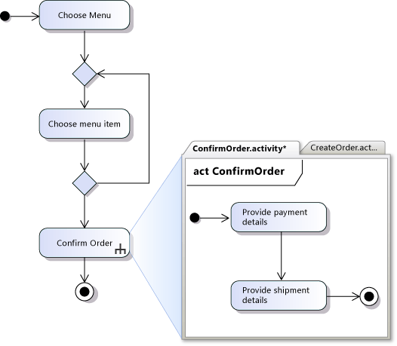

Development View
The development view describes the software organization in its development environment. It focuses on the programmer point of view and is organized in subsytems/libraries. It divides the system in layers that represents the different stages of development.
Component, Package Diagrams

Physical View (Deplyoment View)
The physical view takes describes the mapping of the software onto the hardware. It visualizes the different hardware components and what software they run.
It also takes into account the non-functional requirements like availability, reliability, performance and scalability.
Deplyoment Diagrams
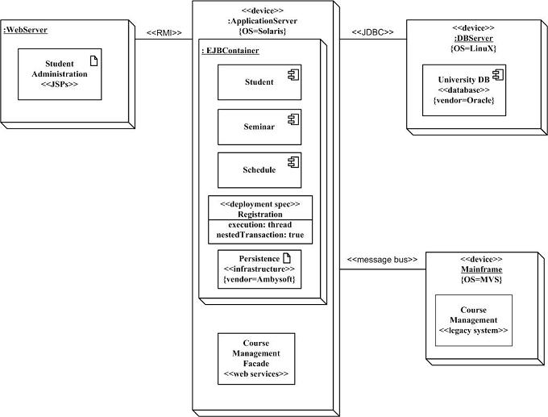

Scenarios (Use Case View)
The description of an architecture is illustrated using a small set of use cases, or scenarios which become a fifth view.

Correspondance among views
Various views are not fully independent, they may be connected with regard to several important characteristics like autonomy, persistence, subordination, distribution.
…..................

Iterative Process
Four phases of Architectural Design:
- sketching
- organizing
- specifying
- optimizing

The architecture has to be developed in an iterative process. It has to be prototyped, tested, measured and analyzed and then redifined in subsequent iterations.

Scenario-driven approach
Scenarios capture the system's critical functionality. We synthesize some of the scenarios by abstracting several user requirements. Then we create a prototyüe architecture and identify major abstractions (classes, processes, subsystems etc.). Next, we organize the architectural elements in 4 views, implement the architecture, test it and measure it.
Then we repeat the process for the next set of scenarios and extend all 4 views of our architecture with the new elements. At this point, we should test the architecture by measuring it und under load in a target environment and detect potential simplifications, commonalitities and opportunities for reuse. Finally, the initinal architecture prototype evolves to become the real system.

Documentation
The Documentation produced during the architectural design is collected in two documents:
- A software architecture document organized by the four views
- A software design guideline which captures important design decisions that must be respected to maintain the architectural integrity.

